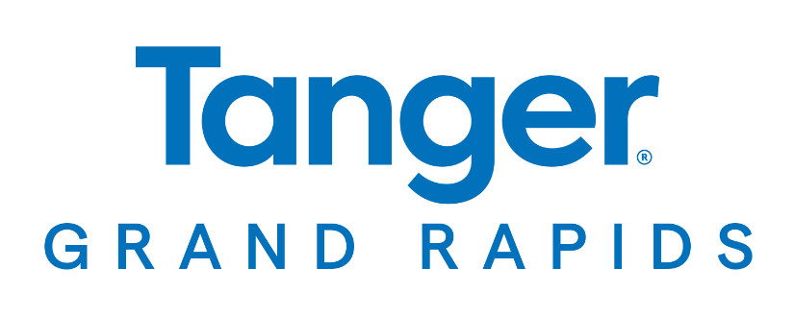

**For More Information:**

Sarah Wynn Benton

BRAVE Public Relations

404-233-3993

sbenton@emailbrave.com

**\*\*MEDIA ADVISORY\*\***

**Tanger Outlets Grand Rapids Invites Community to Fall Harvest Festival, Sept. 21**

*Great Lakes shopping destination welcomes the community to enjoy free cider and donuts along with family-friendly festivities while stocking up on fresh looks for fall*

**GRAND RAPIDS, Mich. (Sept. 13, 2024) – Tanger Outlets Grand Rapids** invites shoppers to celebrate the fall season with a **Fall Harvest Festival** on **Saturday, Sept. 21, from noon – 4 p.m.** Families can enjoy a variety of activities while shopping the latest looks and best deals from leading brands. Festivities include a meet-and-greet with everyone’s favorite blue puppy, a live DJ, face painting, a pumpkin crafting station, a stilt walker, a magician and more.

Tanger’s dynamic mix of top brands and local shops showcases the latest trends and classic styles for everyone. For a complete list of sale offerings, visit [Tanger.com/GrandRapids](https://www.tanger.com/grandrapids).

**WHAT:** **Fall Harvest Festival**

*Activities include free cider and donuts along with character appearances, a live DJ, stilt walker, magician, face painting, pumpkin crafting station and more*

**WHEN:** **Saturday, Sept. 21**

Noon – 4 p.m.

**WHERE:** **Tanger Outlets Grand Rapids**

(In front of Kate Spade and J. Crew)

350 84th St SW

Byron Center, MI 49315

**HOW:** This event is **FREE**and open to the public.

Connect with Tanger Grand Rapids on [Facebook](https://www.facebook.com/TangerOutletsGrandRapids) and [Instagram](https://www.instagram.com/tangeroutletsgrandrapids/). For more information, visit [Tanger.com/GrandRapids](https://www.tanger.com/grandrapids).

